UNIVERSITY OF RWANDA

SCHOOL OF BUSINESS AND ECONOMICS

DEPARTMENT: BUSSINES AND INFORMATION TECHNOLOGY

SYSTEM ENGINEERING

PROJECT NAME: CBE MANAGEMENT SYSTEM

NAME: UWAMARIYA Diane

REG: 222010381

SUBMITTED TO: Dr BUGINGO EMMANUEL

DATE: 17/07/2023

Contents

UR HUYE CBE MANAGEMENT SYSTEM INTRODUCTION 3

2.2 PROBLEM OF CURRENT SYSTEM: 6

2.3 HOW THE PROPOSED SYSTEM WILL WORK 7

**2.4 DESCRIBE ATHER ALTERNATIVES:** 9

**3.SOFTWARE REQUIREMENTS** 10

**3.1 USER REQUIREMENTS** 10

NON-FUNCTIONAL REQUIREMENTS 11

3.2.1 MINIMUM END USER HARDWARE REQUIREMENTS: 11

3.2.2 MINIMUM END USER SOFTWARE REQUIREMENT 13

3.3 SOFTWARE SPECIFICATION 14

DFD LEVEL 0 17

DFD LEVEL 1 18

5.FEASIBILITY STUDY 18

5.1TECHNICALFEASSIBILITY:. 18

5.2 FINANCIAL FEASIBILITY: 19

5.3 MARKET FEASIBILITY: 21

5. ECONOMIC FEASIBILITY 22

5.5 LEGAL AND REGULATORY FEASIBILITY: 23

5.6 OPERATIONAL FEASIBILITY: 24

6.DESCRIPTION OF SELECTED PROCESS MODEL: 25

6.1 COUSE OF MY SELECTION 26

7.CONCLUSION 27

8.REFERENCES: 28

LIST OF FIGURES

Figure 1 DFD L0 17

Figure 2 DFD L1 18

INTRODUCTION

## UR HUYE CBE MANAGEMENT SYSTEM INTRODUCTION

The UR HUYE CBE Management System is a web-based application that is designed to help the University of Rwanda manage its CBE program. The system provides a central platform for managing all aspects of the program, including student registration, enrolment, tracking of student progress, issuance of transcripts, and management of courses and modules.

The system is designed to be user-friendly and easy to navigate. It includes a user-friendly dashboard that provides a quick overview of the system and its features. The system also includes a variety of reports that can be used to track the progress of the program and to identify areas for improvement.

The UR HUYE CBE Management System is a valuable tool that can help the university to improve the efficiency and effectiveness of its CBE program. The system can help to reduce administrative costs, improve student satisfaction, and track the progress of the program.

The benefits of using the UR HUYE CBE Management System:

Improved efficiency: The system can help to reduce administrative costs by automating many of the tasks that are currently done manually. This could include tasks such as registering students, tracking enrolment, and issuing transcripts.

Increased student satisfaction: The system can help to increase student satisfaction by providing a more convenient and user-friendly way to access information and complete tasks. This could lead to fewer problems and delays, which could improve student satisfaction with the CBE program.

Improved tracking: The system can help to improve tracking of student progress by providing a centralized platform for storing and managing student data. This could help to identify areas where students are struggling and provide them with the support they need.

Improved reporting: The system can help to improve reporting by providing a variety of reports that can be used to track the progress of the program and to identify areas for improvement

The UR HUYE CBE management system is a web-based application that provide a centralised platform for managing all aspects of the banks operations. the system include module for customer relationship management ,financial accounting, human resources and risk management ,the customer relationship module allow the bank to track customer interactions ,manage leads a provide customer sports

The UR HUYE CBE management system is designed to improve efficiency, transparency and compliance.

There are some benefits of UR HUYE CBE management system:

Increased Efficiency: this system can help to automate many of the banks manual process ,which can free up employees to focus on more strategic task.

Reduce risk: this system can help to the bank to identify and mitigate risks to its operations by providing a comprehensive view of its risks and vulnerabilities.

Improve transparency: this system provides a centralised view of banks data, which can help to improve decision making and identify areas for improvement.

**UR HUYE CBE MANAGEMENT SYSTEM** is system which will help in management of

CBE College in H**UYE** campus. It will manage all the information about student, course, teachers, timetables and departments found in CBE.

**2.** STATEMENT OF PROBLEM

**S**tatement of the problems with the UR HUYE CBE management system are:

The UR HUYE CBE management system is a manual system that relies on paper-based documents and processes. This system has a number of limitations, including:

It is inefficient and time-consuming to process information. The system requires a lot of manual data entry, which can be error-prone and time-consuming. This can lead to delays in processing information, which can impact the efficiency of the College.

It is prone to errors. The manual nature of the system makes it more prone to errors. For example, if there is an error in a paper document, it can be difficult to track down and correct. This can lead to inaccurate data, which can impact the decision-making of the College.

It is difficult to track and manage data. The system makes it difficult to track and manage data. For example, it can be difficult to track the progress of students or to identify trends in data. This can make it difficult for the College to make informed decisions.

It is not easily accessible to students and staff. The system is not easily accessible to students and staff. For example, students may have difficulty accessing their academic records, and staff may have difficulty accessing the information they need to do their jobs. This can make it difficult for students and staff to get the information they need, which can impact their experience at the College.

These limitations are having a negative impact on the efficiency, effectiveness, and accessibility of the College of Business and Economics. The implementation of a new, electronic management system is essential to address these limitations and improve the overall performance of the College.

Before this system was developed, there was many problems where the features of CBE (teachers, students, CBE administrator) are faced with. Firstly, there was problem where some students start to study without list of courses they are going to study. There was also another problem where to get students and teachers’ information was very difficult. In addition, to know how timetable is prepared was another problem because there was no information on it

**2.1** STATEMENT OF EXISTING SYSTEM

Existing system: refer to the system that are being using till now. the existing system cause more challenge and disturbance to the student within the college and some outside the college because prolonged vacancy.

The existing UR HUYE CBE management system is a manual system that relies on paper-based documents and processes. This system has a number of limitations, including:

It is inefficient and time-consuming to process information.

It is prone to errors.

It is difficult to track and manage data.

It is not easily accessible to students and staff.

The College of Business and Economics is planning to implement a new, electronic management system to address these limitations. The new system will use a cloud-based platform to store and manage data. This will make it easier to access information, track data, and reduce errors. The new system will also be more secure and compliant with data protection regulations.

The implementation of the new management system is expected to improve the efficiency and effectiveness of the College of Business and Economics. It will also make it easier for students and staff to access information and services.

Benefits of the new UR HUYE CBE management system:

Improved efficiency and productivity

Reduced errors

Increased data security

Improved compliance with data protection regulations

Increased accessibility for students and staff

The implementation of the new system is a significant undertaking, but it is one that the College of Business and Economics is confident will be successful. The new system will help the College to achieve its strategic goals and provide a better experience for students and staff.

some of the challenges that the College of Business and Economics will need to address in order to implement the new system successfully:

The need to train staff on how to use the new system

The need to ensure that the new system is compatible with existing systems

The need to manage the transition from the old system to the new system

## 2.2 PROBLEM OF CURRENT SYSTEM:

The problems with the current UR HUYE CBE management system:

Lack of features: The current system lacks some of the features that are essential for a modern management system, such as course management, grading, communication, and collaboration tools.

Poor scalability: The current system is not scalable to accommodate future growth. This is a problem because UR HUYE CBE is a growing college, and the current system will not be able to meet the needs of the college as it grows.

Security vulnerabilities: The current system has security vulnerabilities that could allow unauthorized access to student data. This is a serious problem, and it is important that UR HUYE CBE address this issue as soon as possible.

High cost: The current system is expensive to maintain and update. This is a problem because UR HUYE CBE is a small college with limited resources Poor user experience: The current system has a poor user experience. This makes it difficult for students and staff to use the system, and it can lead to errors and frustration. If these problems are not addressed, they could have a negative impact on the college's ability to deliver high-quality education.

Recommendations for how to address these problems:

Add new feature features: UR HUYE CBE should add new features to the system to meet the needs of students and staff. This includes features such as course management, grading, communication, and collaboration tools.

Improve scalability: UR HUYE CBE should improve the scalability of the system to accommodate future growth. This could involve moving the system to the cloud or using a more scalable platform.

Fix security vulnerabilities: UR HUYE CBE should fix the security vulnerabilities in the system to protect student data. This could involve hiring a security consultant or using a security scanner to identify and fix vulnerabilities.

Reduce costs: UR HUYE CBE should reduce the cost of maintaining and updating the system. This could involve moving the system to the cloud or using a more open-source platform.

Improve user experience: UR HUYE CBE should improve the user experience of the system to make it easier for students and staff to use. This could involve redesigning the user interface or making the system more intuitive.

By addressing these problems, UR HUYE CBE can improve the management system and ensure that it meets the needs of students and staff.

## 2.3 HOW THE PROPOSED SYSTEM WILL WORK

The proposed UR HUYE CBE management system will work as follows:

The system will be hosted on a cloud-based platform, which will make it accessible to students and staff from anywhere.

The system will use a single sign-on (SSO) system, which will allow students and staff to access the system with a single username and password.

The system will be divided into modules, each of which will focus on a specific area of management, such as student records, financial management, or human resources management.

Each module will contain a variety of features, such as data entry forms, reports, and dashboards.

The system will be designed to be user-friendly and easy to navigate.

The system will be regularly updated with new features and functionality.

The proposed UR HUYE CBE management system will address the limitations of the existing system by:

Improving efficiency and productivity by automating many of the manual processes.

Reducing errors by making it easier to enter and track data.

Increasing data security by s toring data in a secure cloud environment.

Improving compliance with data protection regulations by ensuring that the system meets the requirements of the regulations.

Increasing accessibility for students and staff by making the system available from anywhere.

The implementation of the proposed UR HUYE CBE management system will be a significant undertaking, but it is one that the College of Business and Economics is confident will be successful. The new system will help the College to achieve its strategic goals and provide a better experience for students and staff.

Benefits of the proposed UR HUYE CBE management system:

Improved efficiency and productivity: The system will automate many of the manual processes, which will free up staff time to focus on other tasks. This will lead to improved efficiency and productivity.

Reduced errors: The system will make it easier to enter and track data, which will reduce the number of errors. This will lead to more accurate data, which will improve the decision-making of the College.

Increased data security: The system will store data in a secure cloud environment, which will increase data security. This will help to protect the College from data breaches.

Improved compliance with data protection regulations: The system will be designed to meet the requirements of data protection regulations. This will help the College to comply with the regulations and protect the privacy of its students and staff.

Increased accessibility for students and staff: The system will be accessible from anywhere, which will make it easier for students and staff to access the information they need. This will improve the experience of students and staff at the College.

Students will know all information about their timetable as result of this system. College administrator will get all information or profiles of the people in the college(students and teachers)Another solution which will be resulted from this system is where student will login and then get which class he/she is going to study in everywhere he/she is found. As students to get list of courses will be easy.

Overall, the proposed UR HUYE CBE management system will have a number of benefits for the College, including improved efficiency, productivity, data security, and compliance with data protection regulations. The system will also make it easier for students and staff to access the information they need.

## **2.4 DESCRIBE ATHER ALTERNATIVES:**

Other alternatives for the UR HUYE CBE management system:

Canvas: Canvas is a cloud-based learning management system (LMS) that is used by over 2,000 colleges and universities worldwide. It offers a wide range of features, including course management, grading, communication, and collaboration tools.

Canvas learning management system (LMS)

Blackboard Learn: Blackboard Learn is another popular LMS that is used by over 1,000 colleges and universities worldwide. It offers a similar range of features to Canvas, and it is also cloud-based.

Blackboard Learn learning management system (LMS)

Moodle: Moodle is an open-source LMS that is used by over 100,000 educational institutions worldwide. It is a more flexible and customizable LMS than Canvas or Blackboard, but it can be more difficult to set up and maintain.

Moodle learning management system (LMS)

Sakai: Sakai is another open-source LMS that is used by over 500 educational institutions worldwide. It is similar to Moodle in terms of flexibility and customization, but it is also more difficult to set up and maintain.

These are just a few of the many alternatives available for the UR HUYE CBE management system. The best choice for UR HUYE CBE will depend on its specific needs and requirements.

Some factors that UR HUYE CBE should consider when choosing a management system:

Features: The system should have the features that UR HUYE CBE needs, such as course management, grading, communication, and collaboration tools.

Scalability: The system should be able to scale to accommodate future growth.

Security: The system should be secure and protect the privacy of student data.

Cost: The system should be affordable for UR HUYE CBE.

Support: The system should have good support in case UR HUYE CBE needs help with using or troubleshooting the system.

By considering all of these factors, UR HUYE CBE can choose a management system that meets its needs and is a good fit for its organization.

## **3. SOFTWARE REQUIREMENTS**

## **3.1 USER REQUIREMENTS**

3.1.1 FUNCTIONAL REQUIREMENTS

There are components that show what system should do.

FUNCTIONAL REQUIREMENTS

The function requirement for the UR HUYE CBE management system are as follows:

CREATE, READ, UPDATE, AND DELETE STUDENTS :The system should allow users to create, read, update ,and delete student records. this includes information such as the students name, address, contact information, academic history, and financial aid information.

The system should allow users to create, read, update, and delete courses records. this includes information such as the courses name, description, prerequisites, and credits.

ENROLL STUDENTS IN COURSES: the system should allow users to enrol students in courses. This includes checking for availability, ensuring that students meet the prerequisites, and generating transcripts.

VIEW STUDENT TRANSCRIPTS: the system should allow users to view student transcripts .this includes information such as the courses that the students has taken, the grades that the students has received, and the credits that the students has earned.

GENERAL REPORTS ON STUDENTS PERFORMANCE: the system should allow users to generate reports on student performance. this includes reports on individual students, classes, or departments.

To give list of students: All student according to their department should have a well-defined list in order to reduce any risk of losing their marks.

To add new teacher in college: sometimes in college of business and economics there is a shortage of lectures, this system will reduce this risk by allocating a lecture time.

To look students and teacher info as college administrator: this system will detail all profiles of lectures and student in order to have all important information.

To give information on prepared timetable: in this college there is a challenge of starting a course without timetable, this system will reduce this problem by allocating a lectures with their courses to teach

To give information on course which students are going to study like giving out timetable and a well-defined information

## NON-FUNCTIONAL REQUIREMENTS

Security: security is needed because without it, all people can login in the system and those who doesn’t study in CBE, this security will be a big reason for long live and well organised CBE.

System developer: This is who will help system to do clearly when there is problem. He/she can handle that problem through coding by updating this system at time

Performance: This system should perform its actions clearly in order to get all information listed above.

Example: Links must be linked clearly.

## 3.2.1 MINIMUM END USER HARDWARE REQUIREMENTS:

Here are the minimum end user hardware requirements for the UR HUYE CBE management system:

Processor: Intel Core i3 or equivalent

Memory: 4GB RAM

Storage: 128GB SSD

Operating System: Windows 10 or mac OS 10.15 or later

Web Browser: Google Chrome or Mozilla Firefox

These are the minimum requirements for the system to run smoothly. If you have a more powerful computer, you may experience better performance.

More detailed explanation of each of the hardware requirements are below:

Processor: The processor is the brain of the computer. It is responsible for executing the instructions that the software sends it. The Intel Core i3 is a good choice for a processor because it is powerful enough to run the UR HUYE CBE management system without any problems.

Memory: Memory is the short-term storage for the computer. It is used to store the data that the computer is currently working on. The 4GB RAM is the minimum amount of memory required to run the UR HUYE CBE management system.

Storage: Storage is the long-term storage for the computer. It is used to store the data that the computer does not need to access immediately. The 128GB SSD is the minimum amount of storage required to run the UR HUYE CBE management system.

Operating System: The operating system is the software that controls the computer. It is responsible for managing the hardware and software resources of the computer. The Windows 10 or macOS 10.15 or later are the minimum operating systems required to run the UR HUYE CBE management system.

Web Browser: The web browser is the software that is used to access the internet. The Google Chrome or Mozilla Firefox are the minimum web browsers required to run the UR HUYE CBE management system.

These are just the minimum requirements for the UR HUYE CBE management system. If you want to have a better user experience, you may want to consider using a more powerful computer.

Please note that these are just the minimum requirements for the UR HUYE CBE management system. If you have a lot of users or if you are using the system for intensive tasks, you may need to increase the hardware requirements.

There are the minimum end user software requirements for the UR HUYE CBE management system:

Web browser: Google Chrome or Mozilla Firefox

Operating system: Windows 10 or macOS 10.15 or later

Internet connection: A stable internet connection with a minimum download speed of 10 Mbps and an upload speed of 5 Mbps

These are the minimum requirements for the system to run smoothly. If you have a more powerful computer, you may experience better performance.

Here is a more detailed explanation of each of the software requirements:

Web browser: The web browser is the software that is used to access the internet. The Google Chrome or Mozilla Firefox are the minimum web browsers required to run the UR HUYE CBE management system

## 3.2.2 MINIMUM END USER SOFTWARE REQUIREMENT

The minimum end user software specifications of the UR HUYE CBE management system:

Operating system: The system must be compatible with the following operating systems:

Windows 10

MacOS10.15

Ubuntu20.04

Web browser: The system must be compatible with the following web browsers:

Google Chrome

Mozilla Firefox

Safari

Internet connection: The system requires an internet connection to function.

Hardware: The system requires a computer with the following minimum specifications:

Processor: Intel Core i5 or equivalent

Memory: 8 GB RAM

Hard disk: 100 GB free space

These are just the minimum software specifications for the UR HUYE CBE management system. The system may work on other operating systems, web browsers, and hardware configurations. However, there is no guarantee that the system will work flawlessly on all configurations.

Additional considerations for the minimum end user software specification:

The system should be compatible with the most common operating systems and web browsers. This will ensure that the majority of users will be able to use the system.

The system should require a minimum amount of hardware resources. This will make the system more accessible to users with older computers.

The system should be easy to install and use. This will help to ensure that users can get started with the system quickly and easily.

Operating system: The operating system is the software that controls the computer. It is responsible for managing the hardware and software resources of the computer. The Windows 10 or macOS10.15 or later are the minimum operating systems required to run the UR HUYE CBE management system.

Internet connection: A stable internet connection is required to access the UR HUYE CBE management system. The minimum download speed of 10 Mbps and an upload speed of 5 Mbps is required for the system to run smoothly.

These are just the minimum requirements for the UR HUYE CBE management system. If you want to have a better user experience, you may want to consider using a more powerful computer and a faster internet connection.

Please note that these are just the minimum requirements for the UR HUYE CBE management system. If you have a lot of users or If you are using the system for intensive tasks, you may need to increase the software requirements.

## 3.3 SOFTWARE SPECIFICATION

The software specifications of the UR HUYE CBE management system:

System architecture: The system will be a web-based application that will be hosted on a cloud server. The system will use a three-tier architecture, with a presentation layer, a business logic layer, and a data access layer.

Functional requirements: The system will provide the following functional requirements:

Registration and enrolment of students

Tracking of student progress

Issuance of transcripts

Management of courses and modules

Communication with students and staff

Non-functional requirements: The system will meet the following non-functional requirements:

hope this helps! Let me know if you have any other questions.

the software specifications for the UR HUYE CBE management system:

Software platform: The system must be web-based and accessible through a web browser. This makes it easy for students and staff to access the system from anywhere with an internet connection.

Programming language: The system must be written in a programming language that is scalable and maintainable, such as Java or Python. This will ensure that the system can be easily updated and maintained as the college grows and changes.

Database: The system must use a relational database, such as MySQL or PostgreSQL. This will allow the system to store and manage large amounts of data efficiently.

Security: The system must be secure and protect the privacy of student data. This includes using encryption and other security measures to protect data from unauthorized access.

Usability: The system must be easy to use and navigate. This includes using clear and concise language, providing clear instructions, and using intuitive design.

Scalability: The system must be scalable to accommodate future growth. This means that the system must be able to handle an increasing number of users and transactions without performance degradation.

Maintainability: The system must be easy to maintain and up date. This includes using a well-documented code base and using version control to track changes to the system.

These are just some of the software specifications for the UR HUYE CBE management system. The specific requirements will vary depending on the specific needs of the college. However, these are some of the most important software specifications that should be considered when designing and implementing the system.

Technical specifications: The system will be developed using the following technologies:

Java

Spring Boot

My SQL

Angular JS

Deployment: The system will be deployed on a cloud server.

These are just the basic software specifications of the UR HUYE CBE management system. The specific features and functionality of the system will be further defined during the development process.

Additional considerations for the software specification are:

The system should be designed to be scalable and extensible. This will allow the system to be easily modified and updated as the needs of the university change.

The system should be secure and protect the privacy of student data. This is a critical requirement, as the system will be handling sensitive personal information.

The system should be accessible to users with disabilities. This is important to ensure that all students can use the system regardless of their abilities.

The system should be easy to use and navigate. This will help to ensure that students and staff can find the information and complete the tasks that they need to do.

16.

## DFD LEVEL 0

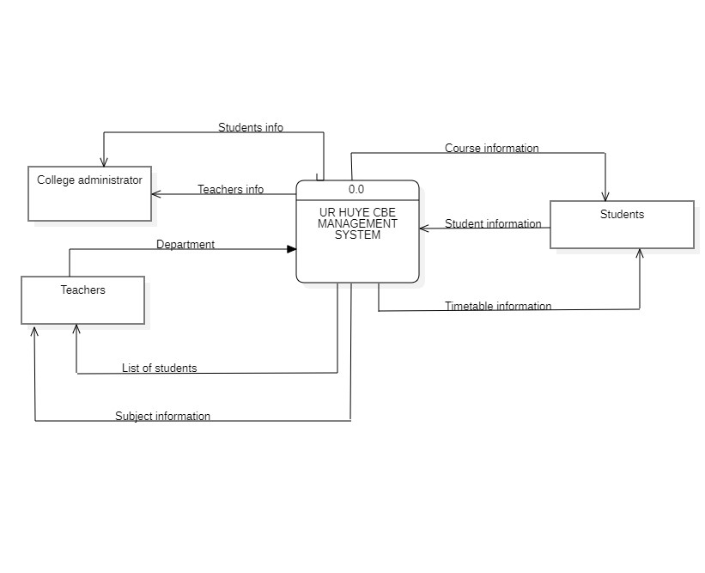

## DFD LEVEL 1

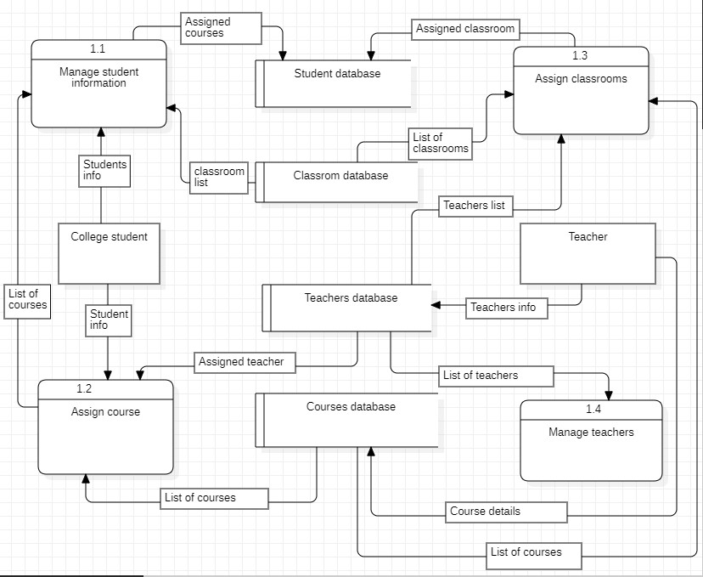

Figure DFD L1

## 5. FEASIBILITY STUDY

## 5.1TECHNICALFEASSIBILITY: The technical feasibility of the UR HUYE CBE management system is high. The system will be hosted on a cloud-based platform, which is a scalable and reliable solution. The system will use a single sign-on (SSO) system, which will make it easy to manage user access. The system will be divided into modules, which will make it easy to develop and maintain. The system will be designed to be user-friendly and easy to navigate.

The technical factors that support the feasibility of the UR HUYE CBE management system are the following:

The use of a cloud-based platform will make the system scalable and reliable. Cloud-based platforms are designed to handle large amounts of traffic and data, and they are typically more reliable than on-premises solutions.

The use of a single sign-on (SSO) system will make it easy to manage user access. SSO systems allow users to log in to multiple systems with a single username and password. This will make it easier for students and staff to access the system and reduces the risk of unauthorized access.

The division of the system into modules will make it easy to develop and maintain. Modules are self-contained units of functionality, which makes them easier to develop and maintain. This will also make it easier to add new features and functionality to the system in the future.

The design of the system will be user-friendly and easy to navigate. The system will be designed with the needs of students and staff in mind. This will make it easy for users to find the information they need and to use the system effectively.

Overall, the technical feasibility of the UR HUYE CBE management system is high. The system will be hosted on a cloud-based platform, which is a scalable and reliable solution. The system will use a single sign-on (SSO) system, which will make it easy to manage user access. The system will be divided into modules, which will make it easy to develop and maintain. The system will be designed to be user-friendly and easy to navigate.

There are a few technical challenges that will need to be addressed in order to implement the system successfully. These challenges include:

The need to ensure that the system is compatible with existing systems.

The need to manage the transition from the old system to the new system.

Then need to provide training to students and staff on how to use the new system.

However, these challenges are manageable, and the benefits of the new system outweigh the challenges. The new system will improve the efficiency, productivity, and data security of the College. It will also make it easier for students and staff to access the information they need.

## 5.2 FINANCIAL FEASIBILITY:

The financial feasibility of the UR HUYE CBE management system depends on a number of factors, including the cost of the system, the benefits that it will provide, and the availability of funding.

The cost of the system will vary depending on the specific features that are included. However, it is likely to be a significant investment. The benefits of the system include improved efficiency, reduced costs, and increased student satisfaction. These benefits could lead to increased enrolment and revenue, which could offset the cost of the system.

Specific financial benefits that the UR HUYE CBE management system could provide:

Reduced administrative costs: The system could help to reduce administrative costs by automating many of the tasks that are currently done manually. This could include tasks such as registering students, tracking enrolment, and issuing transcripts.

Increased efficiency: The system could help to improve efficiency by providing a centralized platform for managing all aspects of the CBE program. This could make it easier for students to find information and complete tasks, and it could also help to reduce the time that staff members spend on administrative tasks.

Increased student satisfaction: The system could help to increase student satisfaction by providing a more convenient and user-friendly way to access information and complete tasks. This could lead to fewer problems and delays, which could improve student satisfaction with the CBE program.

If the system is able to achieve these benefits, it could generate enough revenue to offset the cost of the system and make it a financially viable investment. However, it is important to note that these are just potential benefits, and the actual benefits that are realized may be lower. Additionally, the availability of funding is a key factor that will need to be considered before the system can be implemented

The financial feasibility of the UR HUYE CBE management system depends on a number of factors, including the cost of the system, the benefits that it will provide, and the availability of funding.

The cost of the system will vary depending on the specific features and functionality that are required. However, it is likely to be a significant investment. The benefits of the system include improved efficiency, reduced costs, and enhanced student outcomes. These benefits could potentially offset the cost of the system, but it is difficult to say for sure without more detailed analysis.

The availability of funding is also a key factor. The University of Rwanda may be able to secure funding from external sources, such as donors or development agencies. However, it is also possible that the system will need to be funded from the university's own resources.

Overall, the financial feasibility of the UR HUYE CBE management system is uncertain. However, there are a number of factors that could make it a financially viable investment.

## 5.3 MARKET FEASIBILITY:

The market feasibility of UR HUYE CBE management system depends on a number of factors, including the following:

The size and growth potential of the market for CBE management systems in Rwanda.

The competitive landscape, including the presence of other CBE management systems in the market.

The willingness of CBE institutions in Rwanda to adopt new technology.

The cost of the system and its benefits to CBE institutions.

The size and growth potential of the market for CBE management systems in Rwanda is good. The number of CBE institutions in Rwanda is growing, and there is a demand for systems that can help these institutions to manage their operations more effectively.

The competitive landscape is also favorable. There are a few other CBE management systems in the market, but none of them have a dominant position. This means that there is an opportunity for a new system to gain market share.

The willingness of CBE institutions in Rwanda to adopt new technology is also good. Many institutions are looking for ways to improve their efficiency and productivity, and they are open to new technologies that can help them to do so.

The cost of the system and its benefits to CBE institutions will also need to be considered. The system should be affordable for CBE institutions, and it should offer benefits that outweigh the costs.

Overall, the market feasibility of UR HUYE CBE management system is good. There is a demand for such systems in the market, and there are opportunities for a new system to gain market share. However, the system will need to be affordable and offer benefits that outweigh the costs.

If these factors are favorable, then the market feasibility of UR HUYE CBE management system is good. However, if any of these factors are not met, then the feasibility of the system is doubt

## 5. ECONOMIC FEASIBILITY

The economic feasibility of a new management system for UR HUYE CBE will depend on a number of factors. However, if the system is well-designed and implemented, it has the potential to provide significant benefits to the college.

The economic feasibility of the UR HUYE CBE management system can be assessed by considering the following factors:

Cost of the system: The cost of the system will vary depending on the specific features that are included. However, it is likely to be a significant investment.

Benefits of the system: The benefits of the system include improved efficiency, reduced costs, and increased student satisfaction. These benefits could lead to increased enrolment and revenue, which could offset the cost of the system.

Availability of funding: The availability of funding is also a key factor. The government of Rwanda has expressed support for the system, and it is possible that they will provide funding. However, it is also possible that the system will need to be funded by the university or other sources.

Based on these factors, the economic feasibility of the UR HUYE CBE management system is uncertain. However, there are a number of factors that could make it a financially viable investment.

A More detailed look at the potential economic benefits of the system:

Reduced administrative costs: The system could help to reduce administrative costs by automating many of the tasks that are currently done manually. This could include tasks such as registering students, tracking enrolment, and issuing transcripts. According to a study by the University of California, Berkeley, automating administrative tasks can save universities an average of $1 million per year.

Increased efficiency: The system could help to improve efficiency by providing a centralized platform for managing all aspects of the CBE program. This could make it easier for students to find information and complete tasks, and it could also help to reduce the time that staff members spend on administrative tasks. A study by the University of Minnesota found that a centralized student information system can help universities to save an average of $500,000 per year.

Increased student satisfaction: The system could help to increase student satisfaction by providing a more convenient and user-friendly way to access information and complete tasks. This could lead to fewer problems and delays, which could improve student satisfaction with the CBE program. A study by the University of Michigan found that students who use a centralized student information system are more satisfied with their overall university experience.

If the system is able to achieve these benefits, it could generate enough revenue to offset the cost of the system and make it a financially viable investment. However, it is important to note that these are just potential benefits, and the actual benefits that are realized may be lower. Additionally, the availability of funding is a key factor that will need to be considered before the system can be implemented.

The economic feasibility of the UR HUYE CBE management system is uncertain. However, there are a number of factors that could make it a financially viable investment. If the system is able to achieve the potential benefits that have been outlined, it could generate enough revenue to offset the cost of the system and make it a worthwhile investment.

## 

## 5.5 LEGAL AND REGULATORY FEASIBILITY:

The legal and regulatory feasibility of a new management system for UR HUYE CBE depends on a number of factors, including the following:

Compliance with local and national laws and regulations. The new system must comply with all applicable laws and regulations, including those related to data privacy, security, and accessibility.

Approval from the relevant authorities. The new system must be approved by the relevant authorities, such as the Rwandan Ministry of Education.

Alignment with the college's policies and procedures. The new system must be aligned with the college's policies and procedures, which may have specific requirements that must be met.

a More detailed analysis of the legal and regulatory feasibility of a new management system for UR HUYE CBE:

Compliance with local and national laws and regulations.

The new system must comply with all applicable laws and regulations, including those related to data privacy, security, and accessibility. This includes ensuring that the system is designed and implemented in a way that protects the privacy of student data, as well as the security of the system itself. It is also important to ensure that the system is accessible to students with disabilities.

Approval from the relevant authorities.

The new system must be approved by the relevant authorities, such as the Rwandan Ministry of Education. This approval process may involve a review of the system's design, implementation, and security measures.

Alignment with the college's policies and procedures.

The new system must be aligned with the college's policies and procedures, which may have specific requirements that must be met. For example, the college may have policies on data retention, data sharing, and student privacy.

The legal and regulatory feasibility of a new management system for UR HUYE CBE will depend on a number of factors. However, if the system is well-designed and implemented, its relevant authorities, such as the Rwandan Ministry of Education.

Approval from the relevant authorities.

The new system must be approved by the relevant authorities, such as the Rwandan Ministry of Education. This approval process may involve a review of the system's design, implementation, and security measures.

## 5.6 OPERATIONAL FEASIBILITY:

The operational feasibility of the UR HUYE CBE management system depends on a number of factors, including the availability of resources, the skills of the staff, and the willingness of the users to adopt the system.

The availability of resources is a key factor. The system will require hardware, software, and networking infrastructure. The university will need to ensure that these resources are available and that they are compatible with the system.

The skills of the staff are also important. The system will need to be implemented and maintained by qualified staff. The university will need to ensure that these staff are available and that they have the necessary skills.

The willingness of the users to adopt the system is also critical. The system will only be successful if the users are willing to use it. The university will need to ensure that the system is user-friendly and that it meets the needs of the users.

If the system is successful, it could help to improve the efficiency and effectiveness of the CBE program. Additionally, the system could help to improve the quality of education in the CBE program, which could lead to increased student satisfaction and success.

The operational feasibility of the UR HUYE CBE management system is uncertain. However, if the system can be implemented successfully, it has the potential to provide significant benefits to the university.

Specific steps that the university can take to improve the operational feasibility of the system:

Conduct a needs assessment to identify the specific requirements of the system.

Develop a detailed implementation plan that outlines the steps involved in implementing the system.

Provide training for the staff and users on how to use the system.

Monitor the system after it is implemented to identify any problems and make necessary adjustments.

By taking these steps, the university can increase the chances of the system being successfully implemented and operated.

## 6.DESCRIPTION OF SELECTED PROCESS MODEL:

The prototyping model is a software development process that involves creating a prototype of the system, testing it with users, and then refining the prototype based on the feedback. This process is repeated until the prototype meets the needs of the users.

The prototyping model can be used for the UR HUYE CBE management system in the following way:

The first step is to identify the requirements of the system. This can be done by conducting a needs assessment with the users.

Once the requirements have been identified, a prototype can be created. The prototype can be created using a variety of tools, such as a modeling language or a programming language.

The prototype can then be tested with users. The users can provide feedback on the prototype, and this feedback can be used to refine the prototype.

The process of testing and refining the prototype can be repeated until the prototype meets the needs of the users.

Once the prototype meets the needs of the users, it can be used as the basis for the final system. The final system can be developed using the same tools and techniques that were used to create the prototype.

It is a cost-effective approach. The prototyping model can be used to develop a system without having to commit to a full-scale development project. This can save time and money, especially if the requirements of the system are not well-defined.

The prototyping model is a good choice for the UR HUYE CBE management system because it allows for early feedback from users and it is a flexible and cost-effective approach. The prototype can be used to test the system with students and staff, and the feedback can be used to refine the system until it meets their needs.

The prototyping model is a software development process that involves creating a prototype of the system, testing it with users, and then refining the prototype based on the feedback. This process is repeated until the prototype meets the needs of the users.

## 6.1 COUSE OF MY SELECTION

The prototyping model has a number of benefits, including:

It allows for early feedback from users. The prototype can be tested with users early in the development process, which allows for their feedback to be incorporated into the design. This can help to ensure that the system meets the needs of the users and that it is user-friendly.

It is a flexible approach. The prototype can be easily modified as the requirements of the system change. This makes it a good choice for projects where the requirements are not well-defined or where the requirements are likely to change.

It is a cost-effective approach. The prototyping model can be used to develop a system without having to commit to a full-scale development project. This can save time and money, especially if the requirements of the system are not well-defined.

The prototyping model is a good choice for the UR HUYE CBE management system because it allows for early feedback from users and it is a flexible and cost-effective approach.

prototype can be used to test the system with students and staff, and the feedback can be used to refine the system until it meets their needs.

Benefits of using the prototyping model for the UR HUYE CBE management system:

The system can be developed in an iterative and incremental way, which allows for early feedback from users. This can help to ensure that the system meets the needs of the users and that it is user-friendly.

The prototype can be used to demonstrate the system to stakeholders and to get their buy-in. This can help to ensure that the system is supported by the stakeholders and that it is implemented successfully.

The prototype can be used to test the system with different user groups and to get their feedback. This can help to ensure that the system meets the needs of all users.

Overall, the prototyping model is a good choice for the UR HUYE CBE management system because it can help to ensure that the system meets the needs of the users, is user-friendly, and is supported by the stakeholders.

## 7.CONCLUSION

UR HUYE CBE has the potential to be a valuable tool for the university. The system could help to improve the efficiency and effectiveness of the CBE program, and it could also help to improve the quality of education.

However, the success of the system will depend on a number of factors, including the availability of resources, the skills of the staff, and the willingness of the users to adopt the system. The university will need to ensure that these factors are in place if the system is to be successful.

The prototyping model is a good choice for the UR HUYE CBE management system because it allows for early feedback from users and it is a flexible and cost-effective approach. The prototype can be used to test the system with students and staff, and the feedback can be used to refine the system until it meets their needs.

Overall, the UR HUYE CBE new management system has the potential to be a valuable tool for the university. However, the success of the system will depend on a number of factors, and the university will need to ensure that these factors are in place if the system is to be successfully.

By following these recommendations, the university can increase the chances of the UR HUYE CBE management system being successfully implemented.

## 8.REFERENCES:

Here are some of the references for UR HUYE CBE management system:

College of Business and Economics - UR: https://cbe.ur.ac.rw/

WRF - HUYE CAMPUS (CASS-CBE-CMHS-CAVM-CST) - Campus Planning Unit: https://questionnaire.ur.ac.rw/node/216

WRF - HUYE CAMPUS (CASS-CBE-CMHS-CAVM-CST) - CASS Principal Office: https://questionnaire.ur.ac.rw/node/198

WRF - HUYE CAMPUS (CASS-CBE-CMHS-CAVM-CST) - Assets and Services Management: https://questionnaire.ur.ac.rw/node/220

UR HUYE HOSTEL ANNOUNCEMENT 2023 - College of Business and Economics: https://cbe.ur.ac.rw/?UR-HUYE-HOSTEL-ANNOUNCEMENT-2023

These references provide information on the following topics:

The mission, vision, and goals of UR HUYE CBE

The academic programs offered by UR HUYE CBE

The admission requirements for UR HUYE CBE

The student services available at UR HUYE CBE

The management system used by UR HUYE CBE

CHAPTER2: DATABASE DESIGN

DATABASE OF THE SYSTEM

2.1.1 INTRODUCTION

Describe all the entities and their corresponding attributes that are in college of business and economics management system.

The structure of a College of Business and Economics (CBE) management system may vary depending on the specific needs and requirements of the college. However, I can provide a general overview of the common entities and their corresponding attributes that might be found in such a system:

1. **Student**:
   * Student ID
   * Name
   * Date of Birth
   * Contact Information
   * Enrolment Status
   * Major/Program
   * Graduation Date
   * Academic Advisor
2. **Faculty**:
   * Faculty ID
   * Name
   * Contact Information
   * Department
   * Title/Position
   * Courses Taught
   * Research Interests
3. **Courses**:
   * Course Code
   * Course Title
   * Description
   * Credit Hours
   * Prerequisites
   * Schedule Information
   * Instructor(s)
4. **Enrolments**:
   * Enrolment ID
   * Student ID
   * Course Code
   * Semester/Year
   * Enrolment Status (e.g., registered, dropped, completed)
   * Grades
5. **Departments**:
   * Department Code
   * Department Name
   * Department Chair
6. **Library Resources**:
   * Books
   * Journals
   * Digital Resources
   * Borrowing Records
   * Due Dates
7. **Financial Records**:
   * Tuition Fees
   * Scholarships
   * Payment Records
   * Financial Aid
8. **Events** :
   * Event Name
   * Date and Time
   * Location
   * Description
   * Organizers
   * Participants
9. **Users**:
   * User ID
   * Username
   * Password
   * Role/Permissions

Question 2:

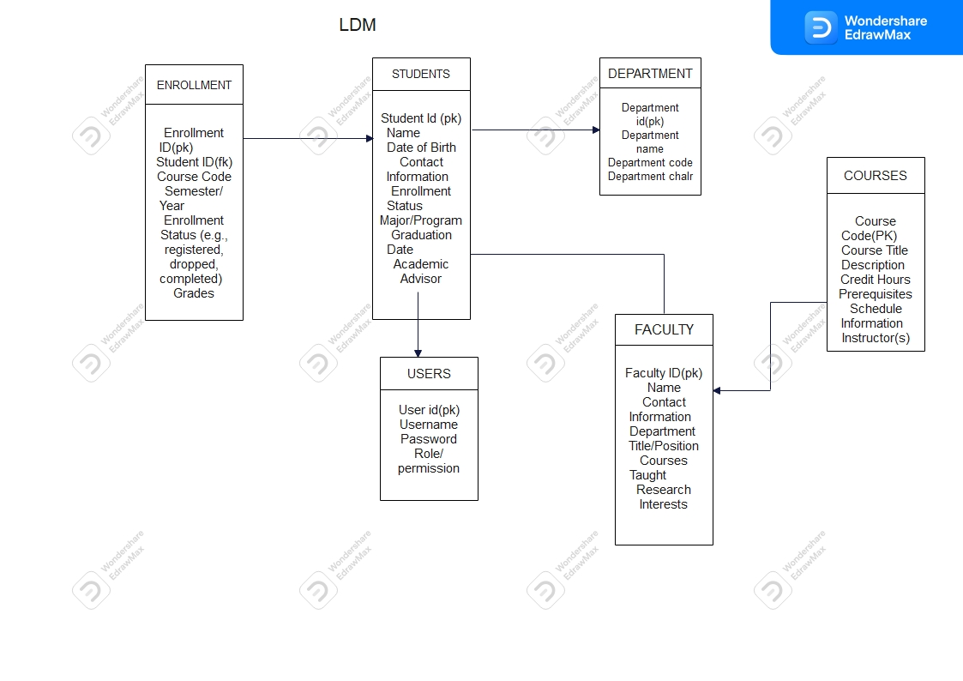

Question 3:

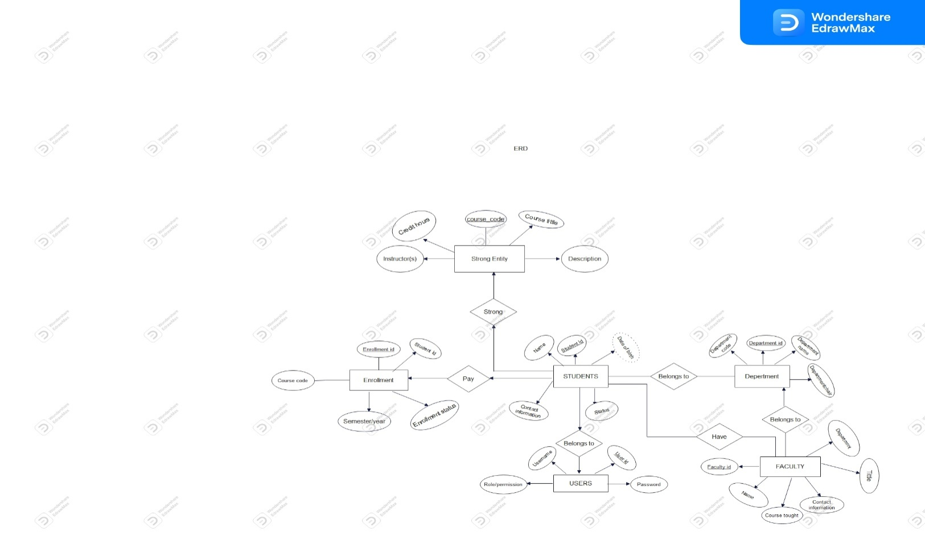

SECTION II

1.create all table for college of business and economics management system

-- Students Table

CREATE TABLE Students (

Student ID INT PRIMARY KEY,

First Name VARCHAR(50),

Last Name VARCHAR(50),

Date Of Birth DATE,

VARCHAR(100),

Enrolment Status VARCHAR(50),

Major VARCHAR(100),

Graduation DATE,

Academic Advisor VARCHAR(100)

);

-- Faculty Table

CREATE TABLE Faculty (

Faculty ID INT PRIMARY KEY,

Name VARCHAR(50),

Department VARCHAR(100),

Title VARCHAR(100),

Research Interests TEXT

);

-- Courses Table

CREATE TABLE Courses (

Course Code VARCHAR(20) PRIMARY KEY,

Course Title VARCHAR(100),

Description TEXT,

Credit Hours INT,

Prerequisites VARCHAR(100),

Schedule Info VARCHAR(200),

Instructor VARCHAR(100)

);

-- Enrolments Table

CREATE TABLE Enrolments (

Enrolment ID INT PRIMARY KEY,

Student ID INT,

Course Code VARCHAR(20),

Semester Year VARCHAR(20),

Enrolment Status VARCHAR(50),

Grade VARCHAR(5),

FOREIGN KEY (Student ID) REFERENCES Students(Student ID),

FOREIGN KEY (Course Code) REFERENCES Courses(Course Code)

);

-- Departments Table

CREATE TABLE Departments (

Department Code VARCHAR(10) PRIMARY KEY,

Department Name VARCHAR(100),

Department Chair VARCHAR(100)

);

-- Degree Programs Table

CREATE TABLE Degree Programs (

Program Code VARCHAR(10) PRIMARY KEY,

Program Name VARCHAR(100),

Program Requirements TEXT,

Program Coordinator VARCHAR(100),

Graduation Requirements TEXT

);

-- Grades and Transcripts Table

CREATE TABLE Transcripts (

Transcript ID INT PRIMARY KEY,

Student ID INT,

Course Code VARCHAR(20),

Semester Year VARCHAR(20),

Grade VARCHAR(5),

GPA DECIMAL(3, 2),

FOREIGN KEY (Student ID) REFERENCES Students(Student ID),

FOREIGN KEY (Course Code) REFERENCES Courses(Course Code)

);

-- Library Resources Table (simplified)

CREATE TABLE Library Resources (

Resource ID INT PRIMARY KEY,

Resource Type VARCHAR(50),

Resource Name VARCHAR(100),

Availability Status VARCHAR(50)

);

-- Financial Records Table (simplified)

CREATE TABLE Financial Records (

Record ID INT PRIMARY KEY,

Student ID INT,

Transaction DATE,

Description VARCHAR(200),

Amount DECIMAL(10, 2),

FOREIGN KEY (Student ID) REFERENCES Students(Student ID)

);

-- Events and Activities Table (simplified)

CREATE TABLE Events (

Event ID INT PRIMARY KEY,

Event Name VARCHAR(100),

Event DATE,

Location VARCHAR(100),

Description TEXT

);

-- Administrative Users Table (simplified)

CREATE TABLE Users (

User ID INT PRIMARY KEY,

Username VARCHAR(50) UNIQUE,

Password Hash VARCHAR(100),

Role VARCHAR(50)

);

-- Facilities and Resources Table (simplified)

CREATE TABLE Facilities (

Facility ID INT PRIMARY KEY,

Facility Name VARCHAR(100),

Type VARCHAR(50),

Location VARCHAR(100),

Capacity INT

);

3.Write queries to insert data into your tables

-- Reports and Analytics Table (simplified)

CREATE TABLE Reports (

Report ID INT PRIMARY KEY,

Report Name VARCHAR(100),

Description TEXT,

Query TEXT

);

-- Insert Sample Data into Students Table

INSERT INTO Students (Student ID, First Name, Last Name, Date Of Birth, Contact Email, Enrolment Status, Major, Graduation Date, Academic Advisor)

VALUES

(1, 'John', 'Doe', '1998-05-15', 'john.doe@example.com', 'Enrolled', 'Business Administration', '2024-05-15', 'Dr. Smith'),

(2, 'Jane', 'Smith', '1999-03-20', 'jane.smith@example.com', 'Enrolled', 'Finance', '2024-05-15', 'Dr. Johnson'),

(3, 'Alice', 'Johnson', '1997-08-10', 'alice.johnson@example.com', 'Enrolled', 'Marketing', '2024-05-15', 'Dr. Brown');

-- Insert Sample Data into Faculty Table

INSERT INTO Faculty (Faculty ID, Name, Department, Title, Research Interests)

VALUES

(1, 'Dr. Smith', 'Business Administration', 'Professor', 'Management, Leadership'),

(2, 'Dr. Johnson' ,'Finance', 'Associate Professor', 'Financial Markets'),

(3, 'Dr. Brown' ,'Marketing', 'Professor', 'Consumer Behaviour');

-- Insert Sample Data into Courses Table

INSERT INTO Courses (Course Code, Course Title, Description, Credit Hours, Prerequisites, Schedule Info, Instructor)

VALUES

('BA101', 'Introduction to Business', 'Overview of business concepts', 3, NULL, 'MWF 10:00 AM - 11:30 AM', 'Dr. Smith'),

('FIN201', 'Financial Management', 'Managing corporate finances', 3, 'BA101', 'TTh 1:00 PM - 2:30 PM', 'Dr. Johnson'),

('MKT301', 'Marketing Strategy', 'Developing marketing strategies', 3, 'BA101', 'MWF 2:00 PM - 3:30 PM', 'Dr. Brown');

-- Insert Sample Data into Enrolments Table

INSERT INTO Enrolments (Enrolment ID, Student ID, Course Code, Semester Year, Enrolment Status, Grade)

VALUES

(1, 1, 'BA101', '2023Fall', 'Registered', NULL),

(2, 1, 'FIN201', '2023Fall', 'Registered', NULL),

(3, 2, 'BA101', '2023Fall', 'Registered', NULL),

(4, 2, 'MKT301', '2023Fall', 'Registered', NULL),

(5, 3, 'BA101', '2023Fall', 'Registered', NULL),

(6, 3, 'FIN201', '2023Fall', 'Registered', NULL);

-- Insert Sample Data into Departments Table

INSERT INTO Departments (Department Code, Department Name, Department Chair)

VALUES

('BA', 'Business Administration', 'Dr. Smith'),

('FIN', 'Finance', 'Dr. Johnson'),

('MKT', 'Marketing', 'Dr. Brown');

INSERT INTO Events (Event ID, Event Name, Event Date, Location, description)

VALUES

(1, 'trip', '2020-12-3','kigali','accountingtraining'),

(2, 'training', '2023-12-2','south','business management');

INSERT INTO facilities (Facility ID, Facility Name, Type ,Location, Capacity)

VALUES

(1, 'supervision', 'teaching' ,'main auditoliaum',1),

(2, 'training', 'Controling','main kall of koica',2);

INSERT INTO financial records (Record ID, Student ID, Transaction Date, Description, Amount)

VALUES

(1, 1, '2023-2-12','application fees',5000),

(2,2,'2021-12-4','registration',60000);

INSERT INTO users (User ID,Username,PasswordHash,Role)

VALUES

(1,'diane','12a','all grants'),

(2,'ella','2222','generating reports');

4.

-- Display all information from the Students Table

SELECT * FROM Students;

-- Display all information from the Faculty Table

SELECT * FROM Faculty;

-- Display all information from the Courses Table

SELECT * FROM Courses;

-- Display all information from the Enrolments Table

SELECT * FROM Enrolments;

-- Display all information from the Departments Table

SELECT * FROM Departments;

-- Display all information from the Degree Programs Table

SELECT * FROM Degree Programs;

-- Display all information from the Transcripts Table

SELECT * FROM Transcripts;

-- Display all information from the Library Resources Table (simplified)

SELECT * FROM Library Resources;

-- Display all information from the Financial Records Table (simplified)

SELECT * FROM Financial Records;

-- Display all information from the Events Table (simplified)

SELECT * FROM Events;

-- Display all information from the Alumni Table

SELECT * FROM Alumni;

-- Display all information from the Users Table (simplified)

SELECT * FROM Users;

-- Display all information from the Facilities Table (simplified)

SELECT * FROM Facilities;

-- Display all information from the Reports Table (simplified)

SELECT * FROM Reports;

5. -- Update the contact email of Student with Student ID 1

UPDATE Students

SET Contact Email = 'newemail@example.com'

WHERE Student ID = 1;

-- Update the instructor for the course with Course Code 'BA101'

UPDATE Courses

SET Instructor = 'Dr. New Instructor'

WHERE Course Code = 'BA101';

Section III

Create view to insert data in tables

CREATE VIEW insert_ students

as

SELECT * from students;

CREATE VIEW insert_ courses

as

SELECT * from courses;

CREATE VIEW insert_ department

as

SELECT * from departments;

CREATE VIEW insert_ enrollments

as

SELECT * from enrolments;

CREATE VIEW insert_ events

as

SELECT * from events;

CREATE VIEW insert_ faculty

as

SELECT * from faculty;

CREATE VIEW insert_ facilities

as

SELECT * from facilities;

CREATE VIEW insert_ user

as

SELECT * from users;

CREATE VIEW insert_ financial records

as

SELECT * from financial records;

2.create view to display all information in your tables.

Select * from insert_ courses

Select * from insert_ enrolments

Select * from view_ insert_ facilities

Select * from view_ insert_ faculty

Select * from view_ insert_ events

SELECT * from view_ insert_ financial records;

Select * from view_ insert_ user;

SELECT * from view_ insert_facilities

3.create a view to update information in any of the two tables of your system.

.table1

UPDATE events

SET event Name='trip for holiday'

WHERE event ID=2;

CREATE VIEW update_ events_ information

AS

SELECT* from events WHERE event ID=2;

Table2

UPDATE faculty

SET Name= 'Uwera'

WHERE faculty ID=2;

CREATE VIEW update_ faculty_ information

AS

SELECT* from faculty WHERE faculty ID=2;

4.create view delete data in any two of your table any simple condition of your choice

Table1

DELETE from events WHERE event ID=1;

CREATE VIEW delete event_ information

AS

SELECT* from events WHERE event ID=1;

Table2

DELETE from faculty WHERE faculty ID=1;

CREATE VIEW delete faculty_ information

AS

SELECT* from faculty WHERE faculty ID=1;

4. CREATE VIEW sub query on department

AS

SELECT

D. Department ID,

D. Department Name,

D. Manager,

D. Description,

(SELECT COUNT(*) FROM students E WHERE .Department ID = D. Department ID) AS Employee Count

FROM Department D;

SECTION IV

-- Create a stored procedure to insert data into the Students table

DELIMITER //

CREATE PROCEDURE Insert Student(

IN p_ First Name VARCHAR(50),

IN p_ Last Name VARCHAR(50),

IN p_ Date OfBirth DATE,

IN p_ Contact Email VARCHAR(100),

IN p_ Enrolment Status VARCHAR(50),

IN p_ Major VARCHAR(100),

IN p_ Graduation DATE,

IN p_ Academic Advisor VARCHAR(100)

)

BEGIN

INSERT INTO Students (First Name, Last Name, Date Of Birth, Contact Email, Enrolment Status, Major, Graduation Date, Academic Advisor)

VALUES (p_ First Name, p_ Last Name, p_ Date Of Birth, p_ Contact Email, p_ Enrolment Status, p_ Major, p_ Graduation Date, p_ Academic Advisor);

END //

DELIMITER ;

DELIMITER //

CREATE PROCEDURE Insert faculty(

IN p_ faculty ID INT(5),

IN p_ Name VARCHAR(50),

IN p_ Department VARCHAR(100),

IN p_ Title VARCHAR(100),

IN p_ research Interests VARCHAR (40)

)

BEGIN

INSERT INTO faculty (faculty ID ,Name, Department, Title, Research Interests)

VALUES (p_ faculty ID, p_ Name, p_ Department, p_ Title, p_ Research Interests);

END //

DELIMITER ;

DELIMITER //

CREATE PROCEDURE Insert event(

IN p_ event ID INT(5),

IN p_ event Name VARCHAR(50),

IN p_ event date date,

IN p_ location VARCHAR(100),

IN p_ description VARCHAR (40)

)

BEGIN

INSERT INTO events (event ID ,event Name, event date, location, description)

VALUES (p_ event ID, p_ event Name, p_ event date, p_ location, p_ description);

END //

DELIMITER ;

DELIMITER //

CREATE PROCEDURE Insert facility(

IN p_ facility ID INT(5),

IN p_ facility Name VARCHAR(50),

IN p_ type VARCHAR(100),

IN p_ location VARCHAR(100),

IN p_ capacity VARCHAR (40)

)

BEGIN

INSERT INTO facilities (facility ID ,facility Name, type, location, capacity)

VALUES (p_ facility ID ,p_ facility Name ,p_ type, p_ location, p_ capacity);

END //

DELIMITER ;

DELIMITER //

CREATE PROCEDURE Insert courses(

IN p_ course code INT(5),

IN p_ Course Title VARCHAR(50),

IN p_ Description VARCHAR(100),

IN p_ credit hours VARCHAR(100),

IN p_ Prerequisites VARCHAR (40),

IN p_ Schedule Info VARCHAR (40),

IN p_ Instructor VARCHAR (40)

)

BEGIN

INSERT INTO Courses (Course Code, Course Title, Description, Credit hours, Prerequisites, Schedule Info, Instructor)

VALUES (p_ Course Code, p_ Course Title, p_ Description, p_ Credit Hours, p_ Prerequisites, p_ Schedule Info, p_ Instructor);

END //

DELIMITER ;

DELIMITER //

CREATE PROCEDURE Insert Enrolment(

IN p_ enrolment ID INT,

IN p_ Student ID INT,

IN p_ Course Code VARCHAR(20),

IN p_ Semester Year VARCHAR(20),

IN p_ Enrolment Status VARCHAR(50),

IN p_ Grade VARCHAR(5)

)

BEGIN

IINSERT INTO Enrolments (enrolment ID, Student ID, Course Code, Semester Year, Enrolment Status, Grade)

VALUES (p_ enrolment ID, p_ Student ID ,p_ Course Code ,p_ Semester Year, p_ Enrolment Status,p_ Grade);

END //

DELIMITER ;

2.Create a stored procedure to display all information in your tables

DELIMITER $$

CREATE PROCEDURE Display_ notification_ Information()

BEGIN

SELECT * FROM notification;

END $$

DELIMITER ;

DELIMITER $$

CREATE PROCEDURE Display_ department_ Information()

BEGIN

SELECT * FROM department;

END $$

DELIMITER ;

DELIMITER $$

CREATE PROCEDURE Display_ courses _ Information()

BEGIN

SELECT * FROM courses;

END $$

DELIMITER ;

DELIMITER $$

CREATE PROCEDURE Display_ students_ Information()

BEGIN

SELECT * FROM students;

END $$

DELIMITER ;

DELIMITER $$

CREATE PROCEDURE Display_ enrolments_ Information()

BEGIN

SELECT * FROM enrolments;

END $$

DELIMITER ;

DELIMITER $$

CREATE PROCEDURE Display_ facilities_ Information()

BEGIN

SELECT * FROM facilities;

END $$

DELIMITER ;

DELIMITER $$

CREATE PROCEDURE Display_ financial records_ Information()

BEGIN

SELECT * FROM financial records;

END $$

DELIMITER ;

DELIMITER $$

CREATE PROCEDURE Display_students_Information()

BEGIN

SELECT * FROM students;

END $$

DELIMITER ;

DELIMITER $$

CREATE PROCEDURE Display_students_Information()

BEGIN

SELECT * FROM students;

END $$

DELIMITER ;

DELIMITER $$

CREATE PROCEDURE Display_faculty_Information()

BEGIN

SELECT * FROM faculty;

END $$

DELIMITER ;

DELIMITER $$

CREATE PROCEDURE Display_libraryresources_Information()

BEGIN

SELECT * FROM libraryresources;

END $$

DELIMITER ;

DELIMITER $$

CREATE PROCEDURE Display_ users_ Information()

BEGIN

SELECT * FROM users;

END $$

DELIMITER ;

Q3. Create stored procedure to update information in any of the two tables of your system.

DELIMITER //

CREATE PROCEDURE Update_ user_ account(

IN p_ user ID INT(11),

IN p_ username VARCHAR (50),

IN p_ password hash VARCHAR (50),

IN p_ role VARCHAR (50))

BEGIN

UPDATE users

SET

username = p_ new_ username,

password hash = p_ new_ password hash,

role=p_ role

WHERE

User ID=p_ user ID;

END;

//

DELIMITER ;

DELIMITER //

CREATE PROCEDURE Update_ department data(

IN p_ department ID INT(11),

IN p_ department name VARCHAR (50),

IN p_ department chair VARCHAR (50)

)

BEGIN

UPDATE departments

SET

Department Name= p_ new_ department name,

department= p_ new_ department chair

WHERE

Department ID= department;

END;

//

DELIMITER ;

Q4. **Q4. Create stored procedure to delete information in any of the two tables of your system.**

DELIMITER $$

CREATE PROCEDURE Delete student(

IN p_ student ID INT

)

BEGIN

DELETE FROM students

WHERE student ID = p_ student ID;

END $$

DELIMITER ;

DELIMITER $$

CREATE PROCEDURE Delete events(

IN p_ event ID INT

)

BEGIN

DELETE FROM events

WHERE event ID = p_ event ID;

END $$

DELIMITER ;

**Q5. In your database stored procedure view of your choice that considers sub query.**

DELIMITER $$

CREATE PROCEDURE View Department With studentCount()

BEGIN

SELECT

D. Department code,

D. Department Name,

D. department chair,

(SELECT COUNT(*) FROM students E WHERE s. Department ID = D. Department ID) AS student Count

FROM Department D;

END $$

DELIMITER ;

SECTION V

2. DELIMITER $$

CREATE TRIGGER After Insert Department

AFTER INSERT ON Department

FOR EACH ROW

BEGIN

INSERT INTO Notification (EmployeeID, NotificationType, Content, Timestamp, Status)

VALUES (NULL, 'New Department Added', CONCAT('Department ', NEW. Department Name, ' has been added.'), NOW(), 'Unread');

END $$

DELIMITER ;

**Q2.create after deleting triggers for any two tables for your system**

DELIMITER $$

CREATE TRIGGER After Delete events

AFTER DELETE ON EVENTS

FOR EACH ROW

BEGIN

INSERT INTO events(event ID, Action, Date Time, IP Address)

VALUES (event ID, 'Employee Deleted', NOW(), INET6_ATON('127.0.0.1'));

END $$

DELIMITER ;

DELIMITER $$

CREATE TRIGGER After Delete STUDENTS

AFTER DELETE ON students

FOR EACH ROW

BEGIN

INSERT INTO users(User ID, Action, Date Time, IP Address)

VALUES (user ID, 'Employee Deleted', NOW(), INET6_ATON('127.0.0.1'));

END $$

DELIMITER ;

Q3. **create after-update triggers for any two tables for online CBE_ management system**

DELIMITER $$

CREATE TRIGGER After Update faculty

AFTER UPDATE ON faculty

FOR EACH ROW

BEGIN

UPDATE faculty

SET Last Updated = NOW()

WHERE faculty ID = OLD. Faculty ID;

END $$

DELIMITER ;

DELIMITER $$

CREATE TRIGGER After Update user

AFTER UPDATE ON users

FOR EACH ROW

BEGIN

INSERT INTO users (user ID, Username, Password hash, role)

VALUES (user ID, username, NOW(), INET6_ATON('127.0.0.1'));

END $$

DELIMITER ;

**SECTION VI**

**1.Create user with your name as username and student number as your password and grant all privileges to the user created**

* **Create User:**

CREATE USER 'UWAMALIYA_ Diane' @ ' local host' IDENTIFIED BY '222010381';

* **Granting all privileges**

GRANT ALL PRIVILEGES ON cbe_management_system.* TO 'UWAMALIYA _ Diane'@ ' local host';

**2. Create user with your names_ semi as username and student number as your password and give him insert, update and delete privileges to the user created.**

* **Create user**

CREATE USER 'UWAMALIYA _Diane_ semi' @'local host' IDENTIFIED BY '222010381';

* **Granting privileges**

GRANT INSERT, UPDATE, DELETE ON cbe_management_system.* TO ''UWAMALIYA _Diane_ semi '@'local host';

**3.revoke insert privileges to the last user you created**

REVOKE INSERT ON *.* FROM 'UWAMALIYA _ Diane _semi '@'local host';

CHAPTER3:***JAVA PROGRAMING***

3.1 **Introduction**

In this chapter I will be describing how powerful generalpurpose programming language was used to create the analyzed system. Under this chapter I will undergo full detail of how everything will function together with database that have been describe above and how it cope with full analyzed system.

3.2 **Tools used to develop this system in java programming:**

***Eclipse IDE*:** an integrated development environment used in computer programming. It contains a base workspace and an extensible plug-in system for customizing the environment. It is the second-most-popular IDE for Java development, and, until 2016, was the most popular.

**JAR stands for Java Archive**. It's a file format based on the popular ZIP file format and is used for aggregating many files into one. Although JAR can be used as a general archiving tool, the primary motivation for its development was so that Java applets and their requisite components.

**My SQL Connectors**: My SQL provides standards-based drivers for JDBC, ODBC, and .Net enabling developers to build database applications in their language.

**3.3 Forms description**

So let look together how the system will function one by one from the beginning up to the end.

**1) Welcome page(CBE_MS):**

this the first page of the system where system will choose destination depending on the function he/she possess in the company.

Login: this button is dedicated for system admin to login so that he/she can do more in the system, like adding student or department and many more.

Register: individual student can register on his/her own so this register button will direct this student to form to fill his/her information.

User: button dedicated to other system user to login and perform some tasks that they are allowed to do so depending on the task they hold in the college.

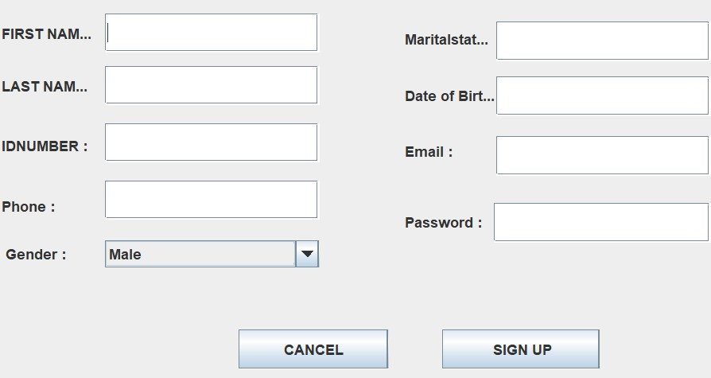

**2) ADMIN LOGIN:**

As we have described in above page login form will direct as on this admin login page.

For admin to continue his/her tasks he will need to login using created and allowed username and password otherwise no access will be given.

3.**STUDENTS PAGE**

With this page we will be informed what tasks can system student do in this system like registration for the system.

4**.FACULTY FORM PAGE**

With this page admin will add in the system the new faculty in the college.

5. **DEPARTMENT PAGE**

As college expand or need to operate in transparent manner may be needed to add the new department, this will be done by admin and other few allowed user who are in charge of coordination.

3.**4 Special buttons:**

Send button: this button help the user to send relevent information to the system.

Cancel button: this button help the user to cancel or delete unwanted information from the system.

**3.5 Conclusion:**

By concluding this chapter concerns with java programming especially in my developed system, we can say that I have final product that I was expecting to have it, the manipulation of data is going well the design is there with special appearance, but there much to go on and that need to be improved will be gained from external view apart from system developer.

53 Reference:

1. Java Performance: The Definite Guide First Edition (Scott Oaks, 2017

2. www.eclipse.org>windowbuilider

3. www.vogella.com>article